HURRICANE PROCEDURE MANUAL
Calais
2026

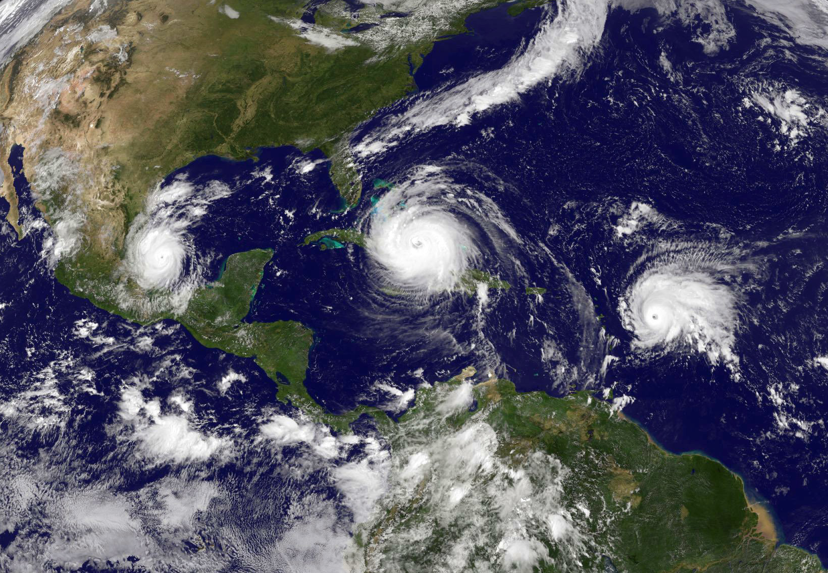

Seacrest Southwest
1044 Castello Dr. Suite 206
Naples, FL 34103
Phone: (239) 261-3440

Table of Contents

HURRICANE PROCEDURES 3
COMMUNICATION PROTOCOL 4
SEASON START 5
1. SUPPLIES 5
2. VENDORS 5
3. MEETINGS 5
4. SITE 5
5. BUILDINGS 6
6. THE DEPARTMENT HEADS RESPONSIBILITIES 5
7. HURRICANE WATCH 5
9. MANAGEMENT OFFICE 6
10. SITE PREPARATION 6
POST HURRICANE 8
1. MANAGEMENT OFFICE 8
2. SURVEY OF DAMAGE 8
3. SECURITY 9
4. OPERATIONS SET-UP 9
5. CLEAN UP 10
6. RESTORATION 10
EMERGENCY CONTACT INFORMATION 11
RESOURCES ……………………………………………………………………………………..12
QUICK REFERENCE LIST ………………………………………………………………………13
INSURANCE COVERAGE FORM……………………………………………………………… 14
DISASTER SUPPLY KIT CHECKLIST …………………………………………………………15
HURRICANE SUPPLY INVENTORY 16

HURRICANE PROCEDURES

The purpose of this manual is to establish procedures for Hurricane Preparations, clean-up, and restoration of normal business operations pre- and post-Hurricane, specifically for Calia condo Association. These procedures help protect the property and our neighbor’s property, minimize losses, ensure individuals’ life and safety, and to re-establish normal operations as quickly as possible.

In connection with our commitment to the safety and well-being of our employees and their respective families, Management may, at its discretion, send staff home early to make their own preparations before returning to the building.

Following a storm, Management will work diligently to restore the building to full operation as quickly as possible. If a curfew is issued or access restrictions detain certain employees from immediately returning to the building, Management will attempt to work with outside contractors to restore the building to full functionality.

COMMUNICATION PROTOCOL (See Hurricane Preparedness – Letter to Owners Form)

In preparation, during, and after the storm, essential communication with Board Members and the community is required. The Property Manager should be communicating through the following methods:

  - Board Meetings – a plan of action needs to be presented.
  - E-Blasts
  - Website updates
  - Property posting

SEASON START

The Hurricane Season officially starts on June 1st of each year and ends on November 30th. The beginning of the season will be the deadline for completing some of the following procedures or the date to begin other procedures. Review the items you are responsible for and plan out your schedule to meet your deadlines. Remember to “plan the work and then work the plan.”

1. SUPPLIES

A. – If applicable, Hurricane Supplies must be inventoried by June 1st of each year to determine that the Hurricane Supplies are at the levels specified on the Inventory Control form. All items that have a shelf life must be replaced. The Property Manager will be responsible for inventory, purchasing additional supplies below the minimum levels, and maintaining supplies through November 30th. All replaced items are to be indicated on the Inventory Control form.

B. - Hurricane Supplies are not to be used as normal operating inventory.

2. VENDORS

Property Managers must ensure that critical Vendors such as Electrical, Waste pick up, Water Remediation, Plumbing, and Landscaping Vendors are prioritizing your Association on their list (for following years please include a signed clause or addendum to the Service Contract to reflect that).

3. MEETINGS

Hurricane Preparedness meetings should be scheduled during the month of June to inform and discuss Hurricane Preparedness. The Property Manager should consult the Board about the established protocol to assist the Association before, during, and after Hurricane. Additionally, the Property Manager will be responsible for scheduling these meetings with staff members and outside vendors (security, landscape, etc.) as appropriate.

4. SITE

- The Property Manager will inspect the landscaping with the Landscaping Contractor beginning of June and will schedule the trimming of all trees and shrubbery by June 30th.

- All site lighting must be inspected to verify that light standards and fixtures are secured, and fasteners securing fixtures are tight.

- The Property Manager should ensure that the drainage system, parking facility, and elevator pits are inspected and cleaned if necessary.

- All amenity equipment or structures are to be inspected to verify everything is secured or protected to the best industry standards.

- All signage is to be inspected, and any signs that are not structurally sound or secured should be repaired.

- Communication with all vendors needs to take place, and contracts need to be reviewed to ascertain that the contract stipulates that the vendors shall be responders after the Hurricane has passed.

5. BUILDINGS

- The Property Manager will inspect all roof areas and verify that all roof-mounted equipment, lighting, and other mechanical equipment are secure. Ensure that access to the roof is secured so no resident may access the roof.

6. MANAGER RESPONSIBILITIES

- The Property Manager is responsible for updating the Emergency Manual, including residents with special needs, and distributing it to staff.

- The Property Manager is responsible for updating the Resident and Board Emergency Manual for distribution electronically (or in paper form if required) to the Association members and Board.

- The Property Manager is responsible for preparing a list of staff cell phone numbers and emergency contacts.

- The Property Manager is responsible for establishing a designated location for the on-site team to gather after the event if the amenities on site are compromised and not accessible or safe.

- The Property Manager is responsible for the Hurricane Inventory, Hurricane Shutters maintenance and servicing (if applicable), common areas, the testing and maintenance of the emergency equipment, roof inspections, and securing building and site fixtures. The Property Manager will also be responsible for maintaining the maximum levels for all first aid supplies.

- The Property Manager will obtain any protective materials to cover and secure on-site office equipment. Materials are to be stored on site until November 30th.

7. HURRICANE WATCH

An email should be sent via email blast to the residents regarding Hurricane Watch directives.

The Property Manager and staff will begin securing the building. A secure perimeter is to be established, and only residents, tenants, employees, and Law Enforcement officials will be permitted on the site. NO vehicular traffic, other than utility vehicular traffic used for the Hurricane Preparations, will be permitted on the property.

The Property Manager will compile a list of vendors that may need access to the property prior to and after the Hurricane to ensure that no one enters until proper identification is shown to security and an “all-clear” has been issued by local authorities.

9. MANAGEMENT OFFICE

- Residents requesting information must be directed to the Management Office. Voice mail messages should be changed with updated information.

- Management will add a complete system backup to an external portable hard drive or cloud. Items of importance should be stored in Appfolio. Back-up should also be performed on any security or FOB systems.

10. SITE PREPARATION (See Hurricane Procedures System Shut Down Form)

- Care must be taken when storing fixtures in the garage to allow free access to the mechanical areas, stairs, elevators, and to vehicular traffic. The Property Manager and Maintenance Staff will be responsible for disconnecting irrigation lines as necessary. All small potted plants must be removed from the common areas and secured. The Maintenance and Housekeeping Staff will be responsible for moving and storing the potted plants.

- All exterior umbrellas and pool furniture must will be stored in the clubhouse along with both BBQs and protected area. The Property Manager and Maintenance Staff will be responsible for ensuring that this is accomplished.

- RESIDENTS are responsible for removing all chairs, tables, benches, and other items from their balconies. The Maintenance Staff is not responsible for storing items that the resident has left unsecured. The staff is only permitted to enter units if instructed by the Manager.

- All trash cans and ash urns are to be removed from the common areas and stored in a secured location. The Maintenance Staff is responsible for storing the trash cans and urns.

- The Property manager will shut off all gas lines to the pool heaters and BBQs .

- Under no circumstances the Evac System shall be shut down completely. This is part of our smoke evacuation system and falls under life safety.

At the time of a Hurricane Warning: Force winds are expected to make landfall within 24 hours.

- When evacuation orders are announced (predominantly properties located in the coastal/flood zones) and/or sustained winds reach 45 mph, the hurricane continues to be an imminent threat. The property manager will begin to shut down the property's central mechanical systems, which include elevators, pool equipment, entrance fountain and lake fountain, etc. This helps ensure that your systems aren’t damaged because of operating during the storm (so that they may be operational after conditions return to normal and power has been restored). The Association may elect to keep one or more mechanical systems operating after the personnel evacuate the building if the Board authorizes it in writing and waives all claims for its decision.

- If hurricane is imminent the clubhouse will have all hurricane shutters put up

- All non-essential main breakers are to be turned off, i.e., elevators, etc. All resident electrical disconnects are to be left on. The Maintenance Staff will be responsible for turning off all electrical systems other than residential units. This will be done at the last possible moment to allow the residents time to prepare their units.

- The Property Manager will be responsible for ensuring that all elevators are parked on a High-Level Floor and shut down and locked out to protect the equipment from possible damage and to prevent anyone from getting trapped in elevator.

- The Calais staff will be responsible for removing all freestanding signs, flag, and flagpole and securing them.

- The Property Manager will verify that all equipment is adequately secured.

11. FINAL WALKTHROUGH

A complete walkthrough is to be performed by the Property Manager and Maintenance Staff. A final walkthrough Checklist is to be filled out. A videotape or photographic record must be made to verify that the property is secured, and all preparations have been completed. Remember that we may be in a mandatory evacuation zone for any Hurricane. All personnel must clear the property when the evacuation order is given.

NOTICE

1. ALL EMPLOYEES ARE TO BE INSTRUCTED, AS THEY LEAVE, TO MAKE EVERY EFFORT POSSIBLE TO REPORT TO WORK AFTER THE HURRICANE IS OUT OF THE AREA. AFTER EVACUATION ORDER IS LIFTED AND THEIR FAMILIES ARE SAFE! THE MANAGER SHOULD MAKE SURE THAT ALL EMPLOYEES HAVE THE PROPERTY MANAGER’S CELL NUMBER AND THE MAINTENANCE SUPERVISOR’S NUMBER.

  - EMPLOYEES MUST PROVIDE MANAGEMENT WITH PHONE NUMBERS AND EMERGENCY NUMBERS (MOBILE PHONE) WHERE THEY CAN BE REACHED.

POST HURRICANE

1. MANAGEMENT OFFICE

The Management Office can be used if the following criteria are met:

  - The building is structurally sound.
  - There is power available.
  - The HVAC equipment is operational.
  - Telephone equipment is operational.

FOR SAFETY REASONS, NO EMPLOYEE IS TO WALK THE PROPERTY UNTIL A SURVEY IS DONE BY THE PROPERTY MANAGER, MAINTENANCE CREW, OR SECURITY STAFF.

UNIT OWNERS WILL BE RETURNING TO THE PROPERTY AND TELEPHONING FOR STATUS. COMPLETE AND FACTUAL INFORMATION MUST BE AVAILABLE.

2. SURVEY OF DAMAGE

Seacrest Southwest recommends that building inspection be performed by qualified licensed and insured professionals for all structural building components such as building envelope, foundation, electrical, plumbing, roofing system, elevator system, HVAC system, etc.

- Members of the Hurricane Team (Manager, Maintenance Supervisor, and Board Members) will conduct site surveys to assess the following:

  - The structural integrity of the buildings.
  - The watertight integrity of the buildings.
  - The condition of the Electrical Systems.
  - The condition of the Underground Utility Systems.
  - Wind and water damage assessment.
  - Damage to HVAC systems/Cooling Towers.
  - Domestic Water Pumps.
  - Landscape damage.
  - Elevator damage.
  - Clean up needs.
  - Dangerous areas, which must be closed off.

After a complete preliminary assessment of the property and Hurricane damage, the Hurricane Team will begin the process of setting up operations, securing the property, and clean-up land restoration, only in areas where it is safe to do so.

- The Property Manager or Maintenance crew will be responsible for taking detailed photos and videos of the property’s condition and any damage.

3. SECURITY

The Property Manager will institute a post-assignment plan to secure the property and barricade unsafe areas. Residents will be allowed to enter the property once it is safe. No one will be permitted to roam the property unescorted.

4. OPERATIONS SET-UP

- If electrical service is active, the Maintenance Staff will begin to power up only common area electrical systems with no signs of water intrusion and no physical damage.

- Property Manager will be responsible for informing Residents on recovery plans. Communication via email to residents should go out if service is available.

- All staff will be responsible for answering management telephone lines and producing memos on status of property and plan of action as directed by the Property Manager.

- The Maintenance Staff will oversee the clean-up operation. They will meet with residents that have arrived on site and assist in assessing damage they may have incurred. Residents should plan for emergency boarding up of their broken windows, water extraction, etc.

5. CLEAN UP

- The Maintenance Staff will be responsible for barricading all unsafe areas and keeping them secure until they can be repaired or cleaned up.

- The Maintenance and Housekeeping Staff will be responsible for the clean-up of debris in the common areas.

- The Property Manager will supervise the removal of water in areas of the building that are flooded and secure areas of the building’s exterior that the storm damaged.

- Residents will be responsible for clean-up in their units.

- Use the AppFolio Eblast feature to notify all residents “upon all clear” to assess damage in their unit.

6. RESTORATION

- The Maintenance staff will be responsible for removing and storing the Hurricane Barricades/Sandbags, etc. All available manpower will assist in this process.

- All Maintenance Staff will be responsible for moving all stored fixtures and furnishings to their original locations.

- The Property Manager will contact the elevator service company to have all elevators inspected. The elevators are not to be placed back in service until inspected by an Elevator Company Technician.

- The Elevator contractor will inspect all elevator pits and remove any standing water. The sump pumps will be inspected and proper operation verified.

- The Property Manager and Maintenance personnel will be responsible for inspecting all building lighting. Fixtures that have been damaged or are not operational are to be repaired or replaced.

- The Property Manager and the Maintenance Staff will conduct a complete inspection of the building’s life safety system to verify the operational integrity of the system.

- The Property Manager will be responsible for obtaining contractors to make repairs beyond the scope of work for Maintenance personnel to perform.

- The Property Manager will be responsible for restocking Hurricane Supplies once the restoration of normal operations is complete.

- Property Manager should organize all critical information collected to assist the Board in opening a claim with the Insurance Company.

EMERGENCY CONTACT NUMBERS

- Property Manager (239) 465-9007
- Front Gate (if applicable)
- Seacrest Southwest Office- Customer Service (239) 261-3440

For outside emergency information or assistance call:
COLLIER COUNTY
- American Red Cross (Local Chapter) (239) 278-3401
- Collier County Animal Services (239) 252-7387
- Collier County Emergency Hotline 311 or (239) 252-8444
- Collier County Sheriff (239) 252-9300
- Collier County Emergency Management (239) 252-3600
- FEMA (800) 621-3362

COLLIER COUNTY

EVACUATION DECISION INFORMATION/TOOL: Click HERE
GENERAL INFORMATION REGARDING EVACUATION AND SHELTERS

• Click HERE for evacuation and general population shelter information.

• Click HERE for a map indicating shelter locations around the county.

• PET SHELTERING INFORMATION: At the time of the approaching disaster, listen to the local media for pet shelter information.

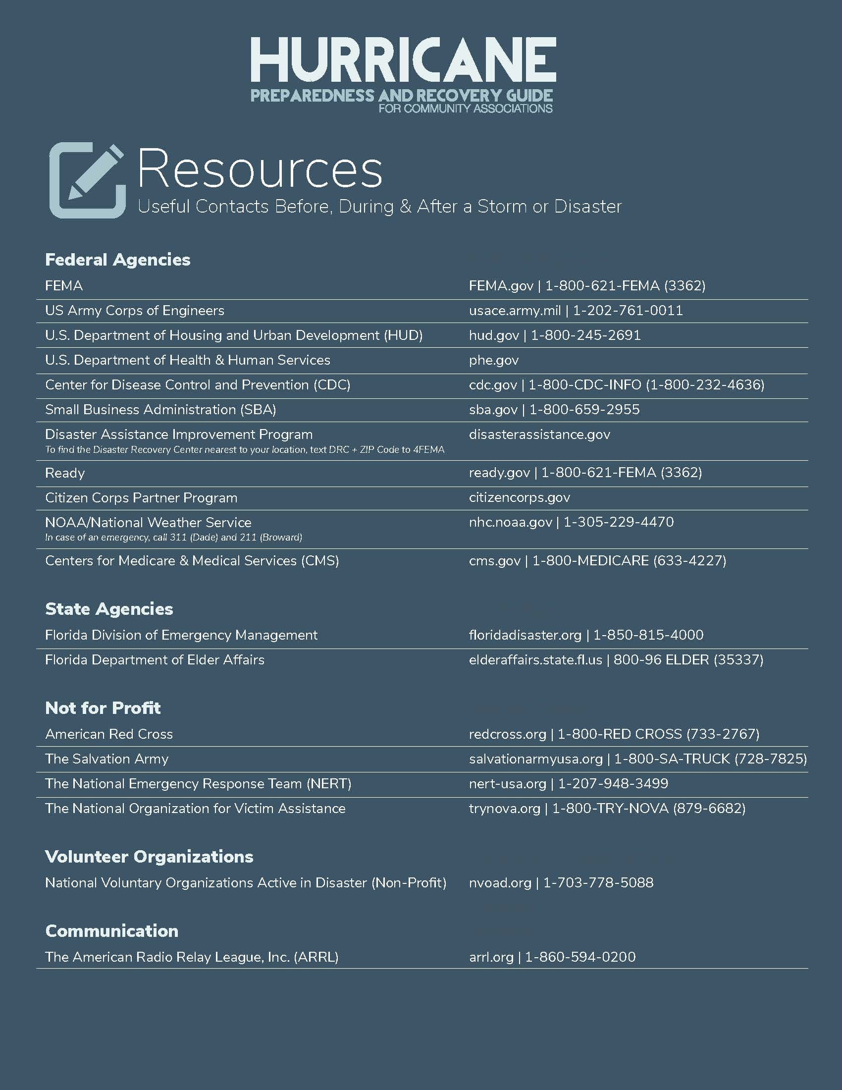
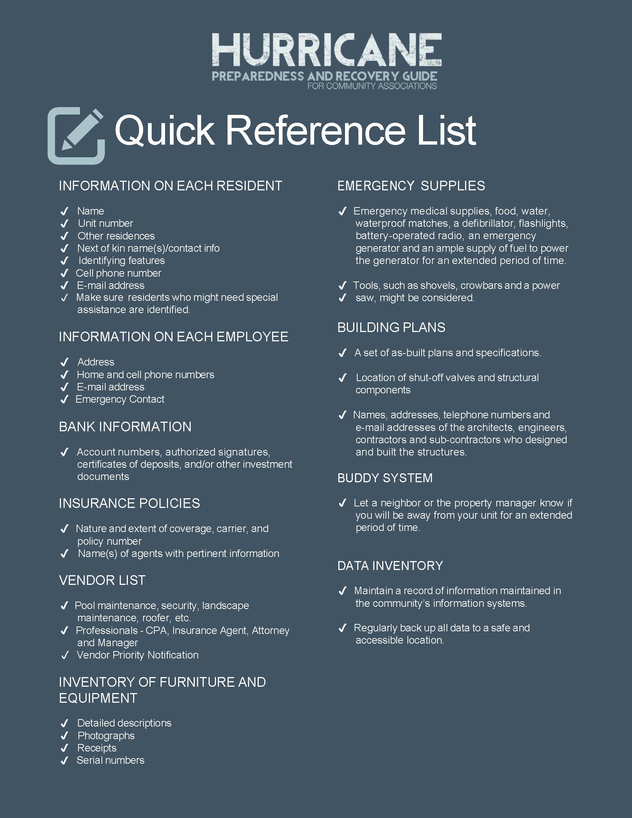

Insurance Coverage Form

Insurance Agent: _Laura Ambrose _______________________________

Insurance Company: Brown and Brown
_____________________________________________

Address: ______________________________________________________

Phone: ____________________________ Email: _____________________

INSURANCE POLICY INFORMATION
Type of Insurance | Policy No. | Deductibles | Policy Limits | Coverage (General Description)

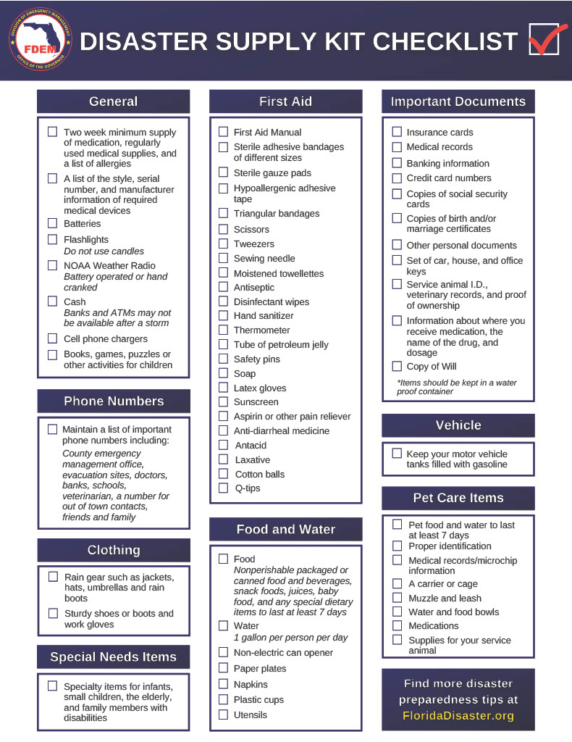
RECOMMENDED HURRICANE SUPPLY INVENTORY

ITEM QUANTITY ESTIMATED COST

1. 3/8” rope
2. Flashlights & lanterns
3. Batteries for radio and flashlights
4. Work gloves
5. First Aid Kits
6. Rain suits
7. Caution tape
8. Duct tape
9. Sandbags
10. Plastic Sheeting/Tarp
11. 2” or 3” Gasoline Water Pumps and Hoses
12. Gasoline cans and gas
13. Rain boots
14. Floor squeegees
15. Mop bucket
16. Chainsaw
17. ½” Plywood Sheets, Nails/Screws
19. Signal Flair
20. Portable Generator
21. Electric Extension Cord.

Acknowledgement of the 2026 Hurricane Procedure Manual:

_____________________________ ______________________________
BOD Member Approval Signature BOD MEMBER NAME & TITLE

_____________________________ ______________________________
BOD Member Approval Signature BOD MEMBER NAME & TITLE

